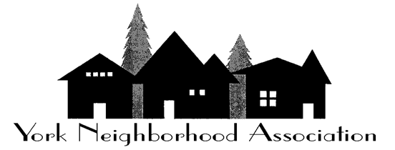
Grant proposal Form
Please present this request to the York Board

Today’s Date: |  |  |  |  |  | Home Phone: |  |  |  |  |  |  |  |  | Cell Phone:
Requester’s name
Mailing Address
E-Mail:
If your request to submit a grant application is approved by the board, you must submit a full copy of all grant applications, supporting documents, and award or regrets letters to the board for archives.

Organization’s name
Address
Amount requested:
Description/ purpose of the project:
How does this Benefit the York Neighborhood?
Proposed use of funds. Include Estimated cost or budget.
(Please be detailed on item costs)
Board Approved |  |  |  |  |  |  | Board Denied
Please provide rational

